Centenary
Association for Private Musical Performance

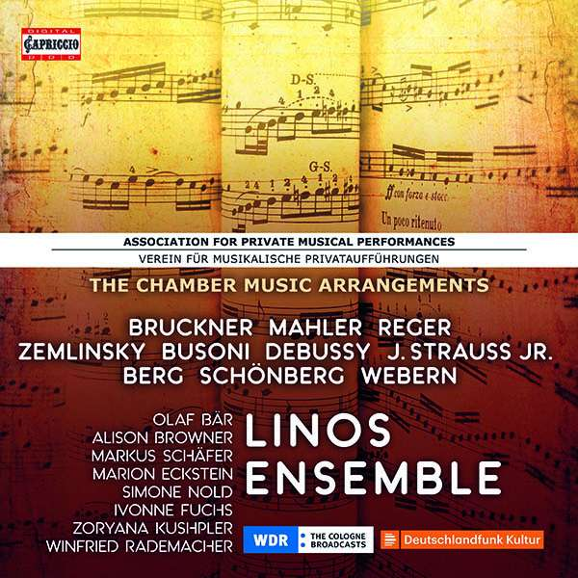

LINOS ENSEMBLE

ASSOCIATION FOR PRIVATE MUSICAL PERFORMANCES
- THE CHAMBER MUSIC ARRANGEMENTS
BRUCKNER · MAHLER · BERG · REGER · SCHOENBERG · WEBERN · DEBUSSY · ZEMLINSKY · BUSONI · STRAUSS (Sohn)
Capriccio 8CD-Set C7265
UPC: 845221072654

Date of release: 14.9.2018

CD 1 ANTON BRUCKNER: Symphony No. 7 (arr. Stein / Eisler / Rankl)
CD 2 GUSTAV MAHLER: Symphony No. 4 (arr. Stein)
Lieder eines fahrenden Gesellen (arr. Schoenberg)
CD 3 GUSTAV MAHLER: Das Lied von der Erde (arr. Riehn)
CD 4 GUSTAV MAHLER: Kindertotenlieder (arr. Schoenberg / Riehn)
ALBAN BERG: Violin Concerto (arr. Schoenberg / Tarkmann)
Altenberg Lieder (arr. Schoenberg / Wagenaar)
CD 5 MAX REGER: Violin Concerto op. 101 (arr. Kolisch)
CD 6 ARNOLD SCHOENBERG: Chamber Symphony op. 9 (arr. Webern)
Six Songs for voice and orchestra, op. 8 (arr. Eisler / Stein / Schoenberg)
ANTON WEBERN: Six Orchestral Pieces, op. 6 (arr. Webern)
CD 7 CLAUDE DEBUSSY: Prélude à l'après-midi d'un faune (arr. Sachs)
MAX REGER: Romantic Suite op. 125 (arr. Schoenberg / Kolisch)
ALEXANDER ZEMLINSKY Six Songs, op. 13 "Maeterlinck-Lieder"
(arr. Stein / Tarkmann)
FERRUCCIO BUSONI: Berceuse élégiaque op. 42 (arr. Stein)
CD 8 JOHANN STRAUSS (Sohn): Waltz-Arrangements (arr. Schoenberg / Berg / Webern)
OLAF BÄR · ALISON BROWNER · MARKUS SCHÄFER · MARION ECKSTEIN · SIMONE NOLD · IVONNE FUCHS· ZORYANA KUSHPLER · WINFRIED RADEMACHER
LINOS ENSEMBLE
Founded in November 1918 by Arnold Schoenberg (1874–1951) and a few of his confidants, the Association for Private Musical Performances constituted perhaps the most progressive and most intensive opportunity for a select Viennese musical circle to familiarize themselves with contemporary and the latest works of the international composers’ scene in the immediate aftermath of the First World War and hence at the time of a dearth of a cultural spirit of optimism and innovation. Schoenberg had a close personal tie with many of the composers performed at the association concerts and sometimes even an amical one, as in the case of Zemlinsky. The association became a nursery for the entire modern music from Richard Strauss and Debussy to Webern, as far as the instrumentation of the works allowed.

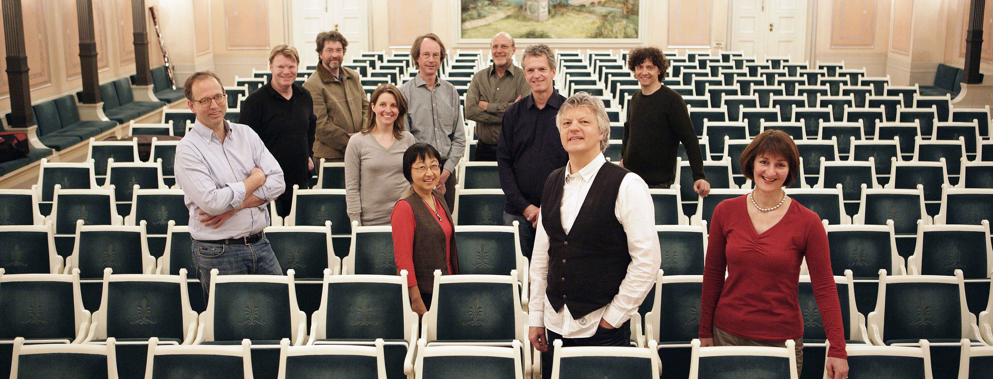

Foto André Mailänder

Linos Ensemble

Successful, fresh, thrilling – all three things for more than fourty years! The Linos Ensemble is constantly accorded such attributes, and this is not just the result of intensive and enthusiastic rehearsals, but has other reasons as well. They include the experience of joint work on interpretation, which is always pions in music. The Neueste Nachrichten in Dresden wrote: ‘It was an exquisite concert the Linos Ensemble gave us. Its name, which derives from Greek mythology, is explained by the title: Linos, the god of rhythm and melody. After what we have heard, we can add: also the god of immense creative power and differentiation of colour’.
The Linos Ensemble was founded by the oboist Klaus Becker in 1977. In its core team of five wind instruments, five strings and piano, it successfully devoted itself to the traditional repertoire of mixed chamber music, before conquering new frontiers: premieres of contemporary compositions, its own concert series in Cologne, journeys of discovery between chamber music and symphony music, special projects on music and language, harmony music to Schubert’s opera Alfonso and Estrella with Hanns Dieter Hüsch or Schoenberg’s Pierrot Lunaire with Salome Kammer.
In the meantime, the ensemble’s repertoire comprises more than 130 works, from Bach to Stockhausen and from the trio to the chamber symphony. The musicians have conquered the CD market with more than 20 excellently reviewed productions, some of which have been awarded prizes such as the recording Louise Farrenc Piano Quintets Nos. 1 and 2, which won the ‘Prize of German Record Criticism’ 3/94 or the Quintet for Piano left-hand of Franz Schmidt, for which the ensemble received the ECHO Klassik 2017. ARD and ZDF have broadcastportrait programmes of the musicians.

Further information: www.linos-ensemble.de

